**Patient Health Quetionnaire-9 (PHQ-9)**

The PHQ-9 is a 9-items tool that screen for the severity of depression. Patient responds to each PHQ-9 item with 1 of 4 options: Not at all, Several days, More than half the days, and Nearly every day. Scoring the PHQ-9 is simple: Not at all is scored as a 0, Several days is scored as a 1, More than half the days is scored as a 2, and Nearly every day is scored as a 3.

To determine the presence of depression, at least item 1 or item 2 must be either a score of 2 or 3 and 5 or more items must be a score of 2 or 3; item 9 must be a score of 1, 2, or 3. The total score of all 9 items indicates the severity of the respondent’s depressive symptoms (Table 1)1.

Table 1.

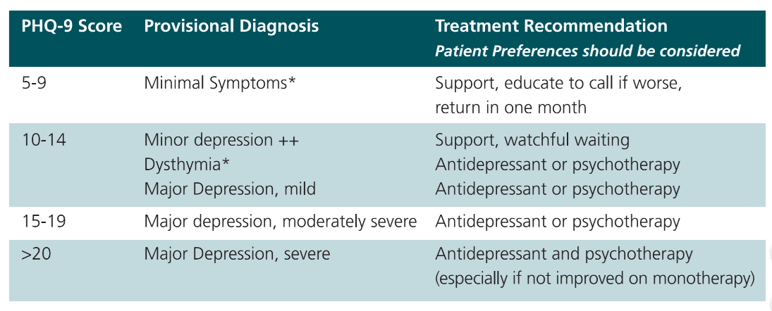

Inference Diagram: Using PHQ-9 to determine the severity of depression

1 Kroenke, K., Spitzer, R. L., & Williams, J., B., W. (2001). The PHQ-9: Validity of a brief depression severity measure. *Journal of General Internal Medicine, 16(9),* 606-613.